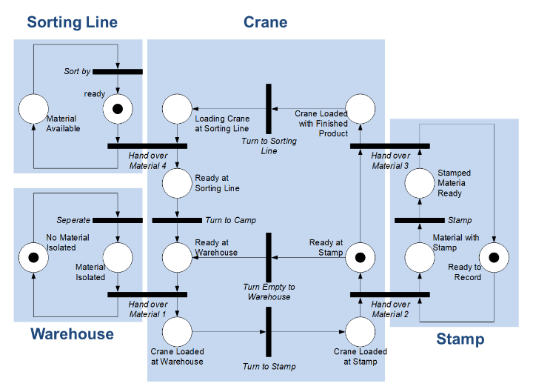

**Error discription**: From the given initial state of the whole petri net a serie of processes at Crane will be implemented: „Ready at Stamp“→“Turn Empty to Warehouse“ →“Ready at Warenhouse“ →“Hand over Material 1“ →“Crane Loaded at Warehouse“ →“Turn to Stamp“ →“Crane Loaded at Stamp“. After this process is implemented twice, the situation in the above screenshot will appear. Petri Net at this situation is dead und cannot be implemented continued.

**Physical significance**: When the mark in the crane returns to the „ready at stamp“ state for the first time, after the material is stamped, crane should remain in the current position until the material is pushed to the sorting line and then return to the warehouse during the transition „Turn to Camp“, but under the current petri net the crane will return to the warehouse directly during the transition “Turn Empty to Warenhouse“, what cause the stamped materials to fail to be transfered to the sorting line.

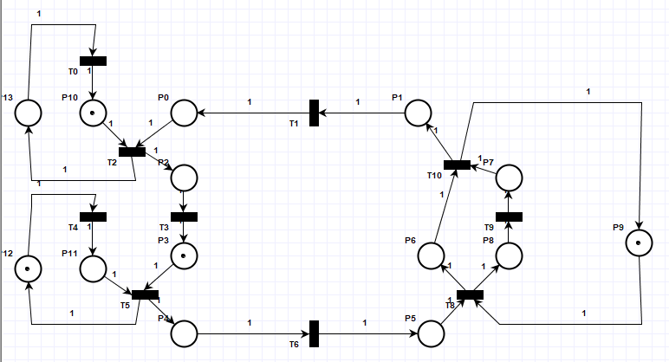

**Modification proposal:** After the stamping („Ready at Stamp“) the material should always immediately following waiting tob e pushed to sorting line. So the transition „Turn Empty to Warehouse“ makes actually no sense. And the initial mark in the Crane should be at the state „Ready at Warehouse“. The first thing that the crane should do is to get Material from warehouse.